# **Computer generation - r**efers to the various phases or eras in the development of computers characterized by distinct technological advancements, changes in hardware architecture, and improvements in processing power.

For many decades we have relied on computers and now they have become an inseparable part of our lives. We cannot imagine our lives without computers are they have made our work easier. These computers have gone through changes over time and have you ever really wondered what a computer actually is? Today we use Laptops for our office work, and tablets for day-to-day calculations or entertainment purposes. These indicate that computers have evolved and undergone changes in their structure, functions and speed over time.

What is the Evolution of the computer?

The evolution of computers started around the 16th century. The evolution of the computer is the process of which transformation of the oldest vacuum tube-based system to the current model system of today’s computers. Long ago, the early primitive people were trailblazers in the use of counting tools, making use of objects like sticks, stones, and bones for their counting needs. The computer we see today has faced many changes, for the betterment via history of computers. It has continuously improved itself in terms of speed, accuracy, size, and price to urge the form of the computer we have today. Here we have discussed the 5 generations of computers and their characteristics.

Generation of Computer

In computers, we use the term “generation” to show the evolution of technology. Earlier, the generation term was used to distinguish the computers in terms of varying hardware but now it all together includes the hardware and software which makes up a computer system. After centuries of evolution that began in the 16th century, the contemporary computer has taken its current form. There are 5 Generations of computers and all of them have been discussed below along with their features.

First Generation Computers (1940-1956)

Second Generation Computers (1956-1963)

Third Generation Computers (1964-1971)

Fourth Generation Computers (1971-Present)

Fifth Generation Computers (Present and Beyond)... Read more at: <https://www.careerpower.in/school/computer/generation-of-computer>

# **How many generations of computers are there?**

Updated: 10/01/2023 by Computer Hope

Computer generations are based on when major technological changes in computers occurred, like going from vacuum tubes to transistors. As of 2023, there are five generations of the computer.

Review each of the generations below for more information and examples of computers and technology that fall into each generation.

## **First generation (1940 - 1956)**

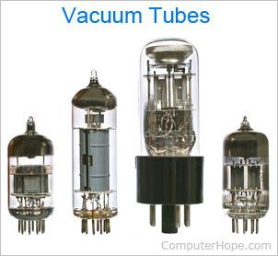

The first generation of computers used [vacuum tubes](https://www.computerhope.com/jargon/v/vacuumtu.htm) as a major piece of technology. Vacuum tubes were widely used in computers from [1940](https://www.computerhope.com/history/1940.htm) through [1956](https://www.computerhope.com/history/1956.htm). Vacuum tubes were larger components and resulted in first-generation computers being quite large in size, taking up a lot of space in a room. Some first-generation computers took up an entire room.

The [ENIAC](https://www.computerhope.com/jargon/e/eniac.htm) (Electronic Numerical Integrator and Computer) is a great example of a first-generation computer. It consisted of nearly 20,000 vacuum tubes, 10,000 [capacitors](https://www.computerhope.com/jargon/c/capacito.htm), and 70,000 [resistors](https://www.computerhope.com/jargon/r/resistor.htm). It weighed over 30 tons and took up a lot of space, requiring a large room to house it. Other examples of first-generation computers include the [EDSAC](https://www.computerhope.com/jargon/e/edsac.htm) (Electronic Delay Storage Automatic Calculator), [IBM 701](https://www.computerhope.com/jargon/num/701.htm), and [Manchester Mark 1](https://www.computerhope.com/jargon/m/mark-1.htm).

## **Second generation (1956 - 1963)**

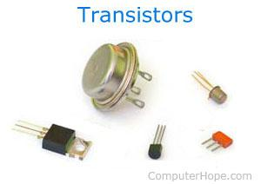

The second generation of computers used [transistors](https://www.computerhope.com/jargon/t/transist.htm) instead of vacuum tubes. Transistors were widely used in computers from [1956](https://www.computerhope.com/history/1956.htm) to [1963](https://www.computerhope.com/history/1963.htm). Transistors were smaller than vacuum tubes and allowed computers to be smaller in size, faster in speed, and cheaper to build.

The first computer to use transistors was the TX-0 and was introduced in 1956. Other computers that used transistors include the IBM 7070, Philco Transac S-1000, and RCA 501.

## **Third generation (1964 - 1971)**

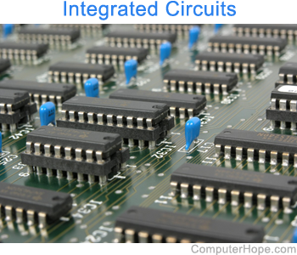

The third generation of computers introduced used [IC](https://www.computerhope.com/jargon/i/ic.htm) (integrated circuit) in computers. Using IC's in computers helped reduce the size of computers even more than second-generation computers, and also made them faster.

Nearly all computers since the mid to late 1960s have utilized IC's. While the third generation is considered by many people to have spanned from [1964](https://www.computerhope.com/history/1964.htm) to [1971](https://www.computerhope.com/history/1971.htm), IC's are still used in computers today. Over 45 years later, today's computers have deep roots going back to the third generation.

## **Fourth generation (1971 - 2010)**

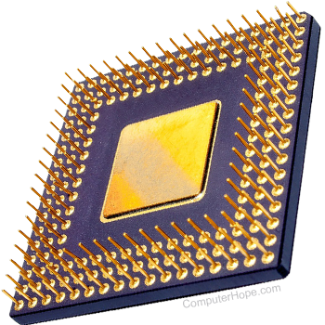

The fourth generation of computers took advantage of the invention of the microprocessor, more commonly known as a [CPU](https://www.computerhope.com/jargon/c/cpu.htm) (central processing unit). Microprocessors, with integrated circuits, helped make it possible for computers to fit easily on a desk and for the introduction of the laptop.

Early computers to use a microprocessor include the [Altair 8800](https://www.computerhope.com/jargon/a/altair.htm), [IBM 5100](https://www.computerhope.com/jargon/i/ibm5100.htm), and Micral. Today's computers still use a microprocessor, despite the fourth generation being considered to have ended in [2010](https://www.computerhope.com/history/2010.htm).

## **Fifth generation (2010 to present)**

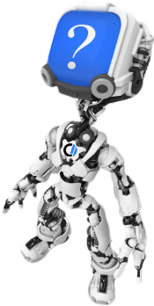

The fifth generation of computers is beginning to use [AI](https://www.computerhope.com/jargon/a/ai.htm) (artificial intelligence), an exciting technology with many potential applications around the world. Leaps have been made in AI technology and computers, but there is still room for much improvement.

One of the more well-known examples of AI in computers is IBM's Watson, which was featured on the TV show Jeopardy as a contestant. Other more recent examples include [ChatGPT](https://www.computerhope.com/jargon/c/chatgpt.htm).

## **Sixth generation (future generations)**

As of [2023](https://www.computerhope.com/history/2023.htm), most still consider us to be in the fifth generation as AI continues to develop. One possible contender for a future sixth generation is the [quantum computer](https://www.computerhope.com/jargon/q/quantum-computer.htm). However, until quantum computing becomes more developed and widely used, it is still only a promising idea.

Some people also consider nanotechnology to be part of the sixth generation. Like quantum computing, [nanotechnology](https://www.computerhope.com/jargon/n/nanotech.htm) is largely still in its infancy and requires more development before becoming widely used.

With a new generation of computers it's also possible how we interact with a computer may also change. New ways of how we may interact with the next generation of computers include only using our voice, AR ([augmented reality](https://www.computerhope.com/jargon/a/augmreal.htm)), VR ([virtual reality](https://www.computerhope.com/jargon/v/vr.htm)), or MR ([mixed reality](https://www.computerhope.com/jargon/m/mixed-reality.htm)).

# **Basic Terms**

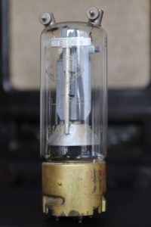

**Vacuum tube** – an electronic device that controls the flow of electrons in a vacuum. It used as a switch, amplifier, or display screen in many older model radios, televisions, computers, etc.

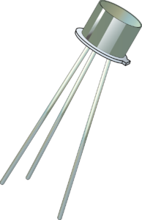

**Transistor** – an electronic component that can be used as an amplifier or as a switch. It is used to control the flow of electricity in radios, televisions, computers, etc.

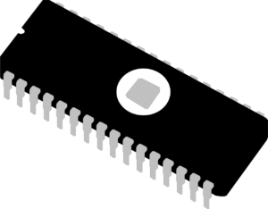

**Integrated circuit (IC)** – a small electronic circuit printed on a chip (usually made of silicon) that contains many its own circuit elements (e.g. transistors, [diodes](https://www.collinsdictionary.com/dictionary/english/diode), resistors, etc.).

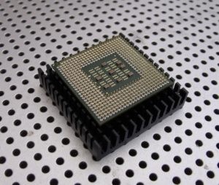

**Microprocessor** – an electronic component held on an integrated circuit that contains a computer’s central processing unit (CPU) and other associated circuits.

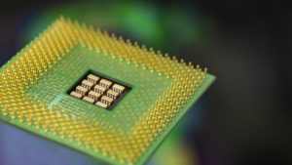

**CPU (central processing unit)** – It is often referred to as the brain or engine of a computer where most of the processing and operations take place (CPU is part of a microprocessor).

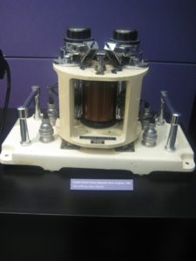

**Magnetic drum** – a cylinder coated with magnetic material, on which data and programs can be stored.

**Magnetic core** – uses arrays of small rings of magnetized material called cores to store information.

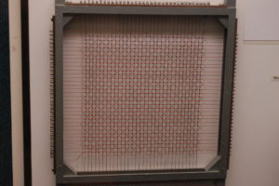

**Machine language** – a low-level programming language comprised of a collection of binary digits (ones and zeros) that the computer can read and understand.

Assembly language is like the machine language that a computer can understand, except that assembly language uses abbreviated words (e.g. ADD, SUB, DIV…) in place of numbers (0s and 1s).

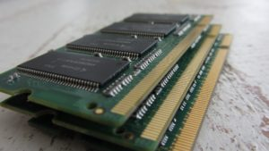**Memory** – a physical device that is used to store data, information and program in a computer.

**Artificial intelligence (AI)** – an area of computer science that deals with the simulation and creation of intelligent machines or intelligent behave in computers (they think, learn, work, and react like humans).

# **First Generation of Computers**

## **Classification of generations of computers**

The evolution of computer technology is often divided into five generations.

| **Generations of computers** | **Generations timeline** | **Evolving hardware** |
| --- | --- | --- |
| First generation | 1940s-1950s | Vacuum tube based |
| Second generation | 1950s-1960s | Transistor based |
| Third generation | 1960s-1970s | Integrated circuit based |
| Fourth generation | 1970s-present | Microprocessor based |
| Fifth generation | The present and the future | Artificial intelligence based |

## **The main characteristics of first generation of computers (1940s-1950s)**

* Main electronic component – vacuum tube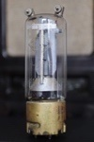
* Main memory – magnetic drums and magnetic tapes
* Programming language – machine language
* Power – consume a lot of electricity and generate a lot of heat.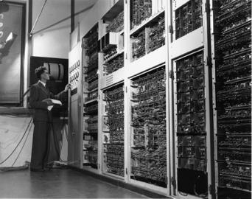
* Speed and size – very slow and very large in size (often taking up entire room).
* Input/output devices – punched cards and paper tape.
* Examples – ENIAC, UNIVAC1, IBM 650, IBM 701, etc.
* Quantity – there were about 100 different vacuum tube computers produced between 1942 and1963.

# **Second Generation of Computers**

## **The main characteristics of second generation of computers (1950s-1960s)**

* 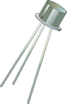Main electronic component – transistor
* Memory – magnetic core and magnetic tape / disk
* 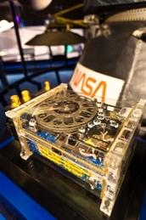Programming language – assembly language
* Power and size – low power consumption, generated less heat, and smaller in size (in comparison with the first generation computers).
* Speed – improvement of speed and reliability (in comparison with the first generation computers).
* Input/output devices – punched cards and magnetic tape.
* Examples – IBM 1401, IBM 7090 and 7094, UNIVAC 1107, etc.

# **Third Generation of Computers**

## **The main characteristics of third generation of computers (1960s-1970s)**

* 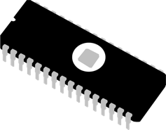Main electronic component – integrated circuits (ICs)
* Memory – large magnetic core, magnetic tape / disk
* Programming language – high level language (FORTRAN, BASIC, Pascal, COBOL, C, etc.)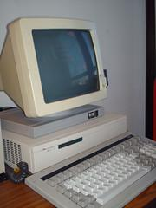
* Size – smaller, cheaper, and more efficient than second generation computers (they were called minicomputers).
* Speed – improvement of speed and reliability (in comparison with the second generation computers).
* Input / output devices – magnetic tape, keyboard, monitor, printer, etc.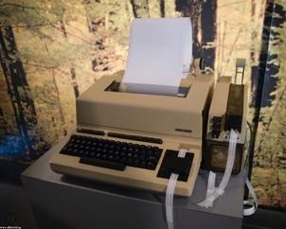
* Examples – IBM 360, IBM 370, PDP-11, UNIVAC 1108, etc.

# **Fourth Generation of Computers**

## **The main characteristics of fourth generation of computers (1970s-present)**

* 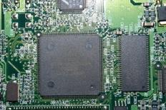Main electronic component – very large-scale integration (VLSI) and microprocessor.
* VLSI– thousands of transistors on a single microchip.
* Memory – semiconductor memory (such as RAM, ROM, etc.)
  + RAM (random-access memory) – a type of data storage (memory element) used in computers that temporary stores of programs and data (volatile: its contents are lost when the computer is turned off).
  + 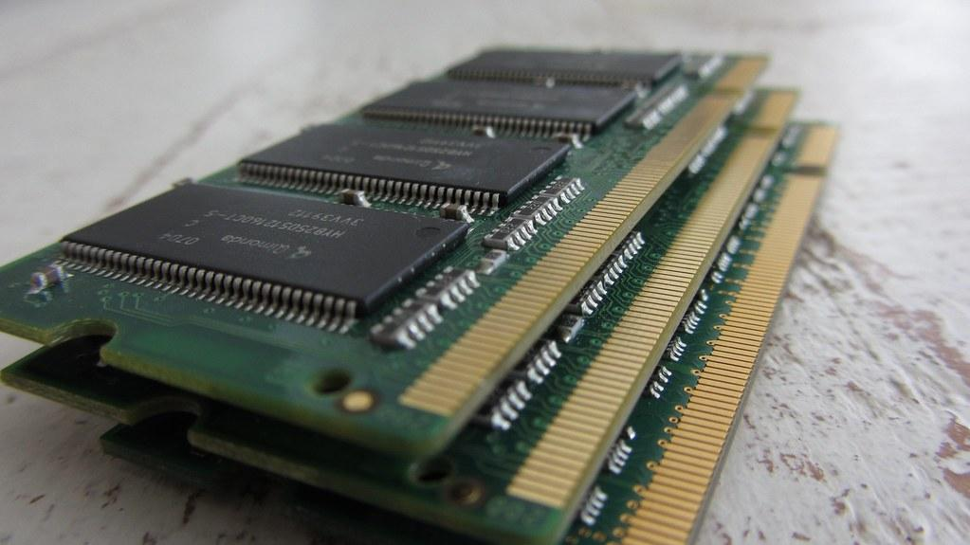ROM (read-only memory) – a type of data storage used in computers that permanently stores data and programs (non-volatile: its contents are retained even when the computer is turned off).
* Programming language – high level language (Python, C#, Java, JavaScript, Rust, Kotlin, etc.).
  + A mix of both third- and fourth-generation languages
* Size – smaller, cheaper and more efficient than third generation computers.
* Speed – improvement of speed, accuracy, and reliability (in comparison with the third generation computers).
* 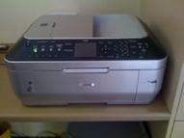Input / output devices – keyboard, pointing devices, optical scanning, monitor, printer, etc.
* Network – a group of two or more computer systems linked together.
* Examples – IBM PC, STAR 1000, APPLE II, Apple Macintosh, etc.

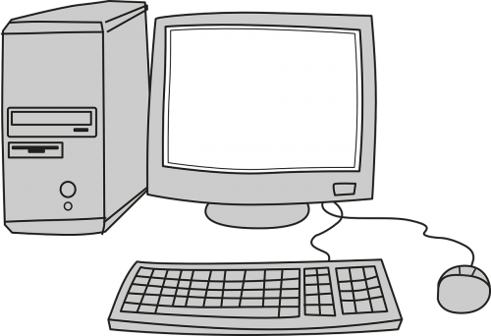

# **Fifth Generation of Computers**

## **The main characteristics of fifth generation of computers (the present and the future)**

* 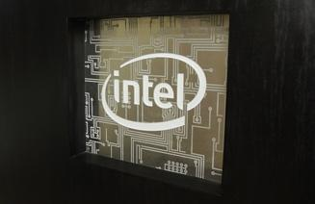Main electronic component: based on artificial intelligence, uses the Ultra Large-Scale Integration (ULSI) technology and parallel processing method.
  + ULSI – millions of transistors on a single microchip
  + Parallel processing method – use two or more microprocessors to run tasks simultaneously.
* Language – understand natural language (human language).
* Power – consume less power and generate less heat.
* Speed – remarkable improvement of speed, accuracy and reliability (in comparison with the fourth generation computers).
* Size – portable and small in size, and have a huge storage capacity.
* 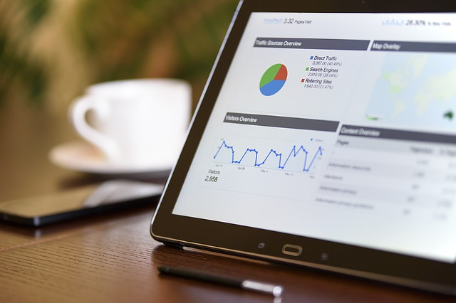Input / output device – keyboard, monitor, mouse, trackpad (or touchpad), touchscreen, pen, speech input (recognise voice / speech), light scanner, printer, etc.
* Example – desktops, laptops, tablets, smartphones, etc.

The computer – this amazing technology went from a government/business-only technology to being everywhere from people’s homes, work places, to people’s pockets in less than 100 years.

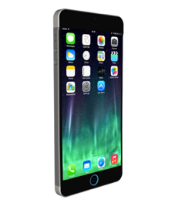

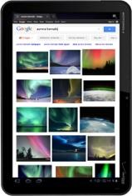

**1. First Generation Computers**

The 1st Generation Computers were introduced using the technology of vacuum tubes which can control the flow of electronics in a vacuum. These tubes are usually used in switches, amplifiers, radios, televisions, etc. The First Generation of Computer was very heavy and large and were not ideal for programming. They used basic programming and didn’t have an operating system, which made it tough for users to do programming on them. The 1st Generation Computers required a big room dedicated to them and also consumed a lot of electricity.

**Some examples of main first-generation computers are-**

ENIAC: Electronic Numerical Integrator and Computer, built by J. Presper Eckert and John V. Mauchly which contained 18,000 vacuum tubes.

EDVAC: Electronic Discrete Variable Automatic Computer, designed by Von Neumann.

UNIVAC: Universal Automatic Computer, developed by Eckert and Mauchly in 1952.

**Characteristics of 1st Generation Computers**

These computers were designed using vacuum tubes.

Programming in these computers was done using machine languages.

The main memory of 1st Generation Computers consisted of magnetic tapes and magnetic drums.

Paper tapes and Punched cards were used as input/output devices in these computers.

These computers were very huge but worked very slowly.

Examples of 1st Generation Computers are IBM 650, IBM 701, ENIAC, UNIVAC1, etc.

**2. Second Generation Computers**

The Second Generation of Computers revolutionized as it started using the technology of transistors instead of bulky vacuum tubes. Transistors are devices made of semiconductor materials that open or close a circuit. These transistors were invented in the Bell Labs which made the Second Generation Computer powerful and faster than the previous ones. Transistors made these computers smaller and generated less heat compared to the vacuum tubes they replaced. The Second Generation of Computers also introduced the use of CPU, memory and input/output units. The programming languages used for the second-generation computers were FORTRAN (1956), ALGOL (1958), and COBOL (1959).

**Characteristics of Second-Generation Computers**

The Second Generation computers used the technology of Transistors.

Machine language and Assembly Languages were used for these computers.

Magnetic core and magnetic tape/disk were used for memory storage.

The Second Generation Computers were smaller in size, consumed less power and generated less heat.

Magnetic tape and punched cards were used as input/output devices.

Some of the examples are PDP-8, IBM1400 series, IBM 7090 and 7094, UNIVAC 1107, CDC 3600, etc.

**3. Third Generation Computers**

The evolution of Third Generation Computers took place with a shift from transistors to integrated circuits also called IC. The Third Generation of Computer was very fast and reliable. The ICs used in these computers were made from silicons and were called silicon chips. A single IC has many transistors, registers, and capacitors built on one thin slice of silicon. This generation of computers has increased memory space and efficiency. Higher-level languages like BASIC (Beginners All-purpose Symbolic Instruction Code) were used and the Minicomputers were introduced in this era.

**Characteristics of Third-Generation Computers**

These computers were built using Integrated Circuits (ICs).

High-level programming languages were used for programming on these computers.

Large magnetic core and magnetic tape/disk were used for memory storage.

Magnetic tape, monitor, keyboard, printer, etc were used as input/output devices.

Some of the examples of Third Generation Computers are IBM 360, IBM 370, PDP-11, NCR 395, B6500, UNIVAC 1108, etc.

**4. Fourth Generation Computers**

The period from 1972 to 2010 is considered the period of the fourth generation of computers. Microprocessor technology was used to develop the Fourth Generation of Computers. The foremost advantage of these computers is that the microprocessor can contain all the circuits required to perform arithmetic, logic, and control functions on one chip. In the Fourth Generation, computers became very small in size and also became portable.

Technologies like multiprocessing, multiprogramming, time-sharing, operating speed, and virtual memory were also introduced by then. During the fourth generation, private computers and computer networks became a reality.

**Characteristics of Fourth-Generation Computers**

The Fourth Generation Computers have been developed using the technology of Very-large-scale integration (VLSI) and the microprocessor (VLSI has thousands of transistors on a single microchip).

Semiconductor memory such as RAM, ROM, etc was used for memory storage.

Input/output devices such as pointing devices, optical scanning, keyboard, monitor, printer, etc were introduced.

Some examples of Fourth Generation Computers are IBM PC, STAR 1000, APPLE II, Apple Macintosh, Alter 8800, etc.

**5. Fifth Generation Of Computers**

The Fifth Generation of Computers has been built using the technology called Artificial Intelligence (AI). This technology encourages computers to behave like humans. Some of the applications of AI have been seen in features like voice recognition, entertainment, etc. The speed of the Fifth Generation of Computers is the highest while the sizes are the smallest. A big improvement has been noticed so far over the years in the various generations of computers in the aspect of speed, accuracy dimensions, etc.

**Characteristics of Fifth Generation of Computers**

The 5th Generation Computers have been built based on artificial intelligence, use the Ultra Large-Scale Integration (ULSI) technology and parallel processing method (ULSI has millions of transistors on a single microchip and the Parallel processing method uses two or more microprocessors to run tasks simultaneously).

These computers understand natural language (human language).

The Fifth-generation computers are portable and smaller in size.

Trackpad (or touchpad), touchscreen, pen, speech input (recognize voice/speech), light scanner, printer, keyboard, monitor, mouse, etc are used as Input/Output devices.

Examples of 5th Generation Computers are Desktops, laptops, tablets, smartphones, etc.

**History of Computer Generation**

The word ‘computer’ was first used in the 16th century for a person who used to do calculations until the 20th century. Women were hired as human computers to carry out all forms of calculations and computations. By the end of the 19th century, the word ‘computer’ was used for the machines that did calculations. Nowadays we use the word for the programmable digital devices that run on electricity.

Before computers were invented, sticks, stones, and bones were used as counting tools. With the evolution of human intellect and the advancement of technology, more computing devices were produced. There are mechanical calculators used by humans before computers. Some of the most famous mechanical calculators are:

Abacus

Pascal’s Calculator

Stepped Reckoner

Arithmometer

Comptometer & Comptograph

Difference Engine

Analytical Engine

The Millionaire

Below we have discussed briefly the early-age computing devices used by mankind.

Abacus

The Chinese are said to have discovered the Abacus some 4,000 years ago. The abacus was built using a wooden rack having metal rods with beads mounted on them. To perform the arithmetic calculations, beads were moved by the abacus operator according to some rules.

Napier’s Bones

John Napier invented Napier’s Bones which was a manually operated calculating device. John used 9 different ivory strips or bones marked with numbers to multiply and divide with the help of this calculating tool. The Napier’s Bone was also the first calculating tool to use decimal points.

Pascaline

A French mathematician-philosopher Biaise Pascal invented the Pascaline between 1642 and 1644. This tool was also called the Arithmetic Machine or Adding Machine and is believed to be the first mechanical and automatic calculator.

Stepped Reckoner or Leibnitz wheel

A German mathematician-philosopher Gottfried Wilhelm Leibnitz developed the Stepped Reckoner or Leibnitz wheel in 1673. This machine was technically an upgrade of Pascal’s invention. The Stepped Reckoner or Leibnitz wheel was a digital mechanical calculator that was made of fluted drums instead of gears.

Difference Engine

Charles Babbage, known as the “Father of Modern Computer designed the Difference engine in the early 1820s. The Difference Engine was a mechanical computer that could perform simple calculations. It was a steam-driven calculating machine designed to solve tables of numbers like logarithm tables.

Analytical Engine

The Analytical Engine was also developed by Charles Babbage in the 1830s. This calculating machine was a mechanical computer that used punch cards as input. These machines were capable of solving any mathematical problem and storing information as a permanent memory.

Tabulating Machine

Herman Hollerith, an American statistician invented the Tabulating Machine in the 1890s which was a mechanical tabulator based on punch cards that was capable of tabulating statistics and recording or sorting data or information.

Differential Analyzer

The Differential Analyzer was the first electronic computer introduced in the United States in 1930. It was an analog device invented by Vannevar Bush. This machine could perform 25 calculations in a few minutes.

Mark I

The major changes in the history of computers began in 1937 when Howard Aiken aimed to invent a machine that could perform calculations of larger numbers. In 1944, IBM and Harvard partnered to build the Mark I computer. The Mark 1 was the first programmable digital computer.

Generations of Computer – MCQs Question and Answer

MCQ 1. What was the first electromechanical computer?

a) ENIAC

b) Colossus

c) Charles Babbage’s Analytical Engine

d) Abacus

Answer: c) Charles Babbage’s Analytical Engine

MCQ 2. Which computer pioneer is often considered the “Father of Computing”?

a) Bill Gates

b) Steve Jobs

c) Alan Turing

d) Tim Berners-Lee

Answer: c) Alan Turing

MCQ 3. Which computer introduced the concept of the mouse and graphical user interface (GUI)?

a) IBM 701

b) Commodore 64

c) Apple Macintosh

d) ENIAC

Answer: c) Apple Macintosh

MCQ 4. What year marked the birth of the World Wide Web?

a) 1969

b) 1983

c) 1991

d) 2000

Answer: c) 1991

MCQ 5. Which computer is considered the first true personal computer?

a) Altair 8800

b) IBM PC

c) Apple I

d) Commodore PET... Read more at: https://www.careerpower.in/school/computer/generation-of-computer